**PSUC Lab Assignment**

Name: Saksham Mamtani Reg No: 200903038

**Lab 8:**

Q) C Program to Find NCR Factorial of a Number

**Code**:

#include <stdio.h>

int Fact(int);

int main()

{

int n, r, ncr;

printf("Please Enter the Values for n and r: \n");

scanf("%d %d", &n, &r);

ncr = Fact(n) / (Fact(r) * Fact(n-r));

printf("Factorial of %d and %d = %d", n, r, ncr);

printf("\nMy name is Saksham");

return 0;

}

int Fact(int Number)

{

int i;

int Factorial = 1;

for (i = 1; i <= Number; i++)

{

Factorial = Factorial * i;

}

return Factorial;

}

**Output** :

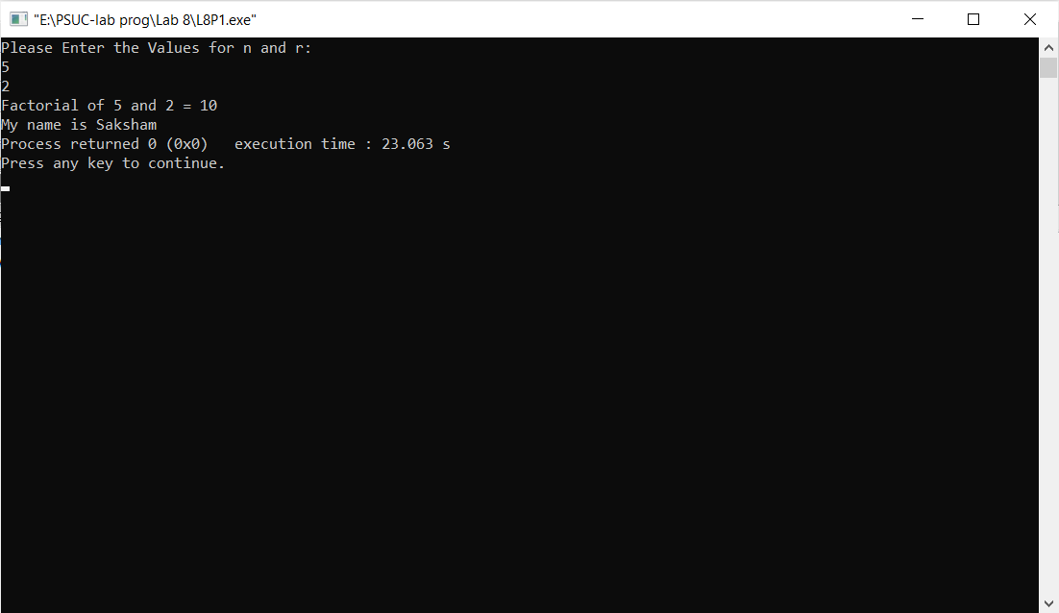

Q2) Write a function Largest to find the maximum of a given list of numbers. Also write a main program to read N numbers and find the largest among them using this function.

**Code**:

#include <stdio.h>

int largest(int arr[],int num)

{

int i=0;

int max = arr[0];

for(i=0;i<num;i++){

if (arr[i] > max)

max = arr[i];}

return max;

}

int main()

{

int arr[100];

int i,num;

printf("Enter the total numbers in the list: \n");

scanf("%d",&num);

printf("Enter the numbers now:\n");

for (i=0;i<num;i++)

scanf("%d",&arr[i]);

printf("Largest in given array is %d", largest(arr,num));

printf("\nMy name is Saksham");

return 0;

}

**Output**:

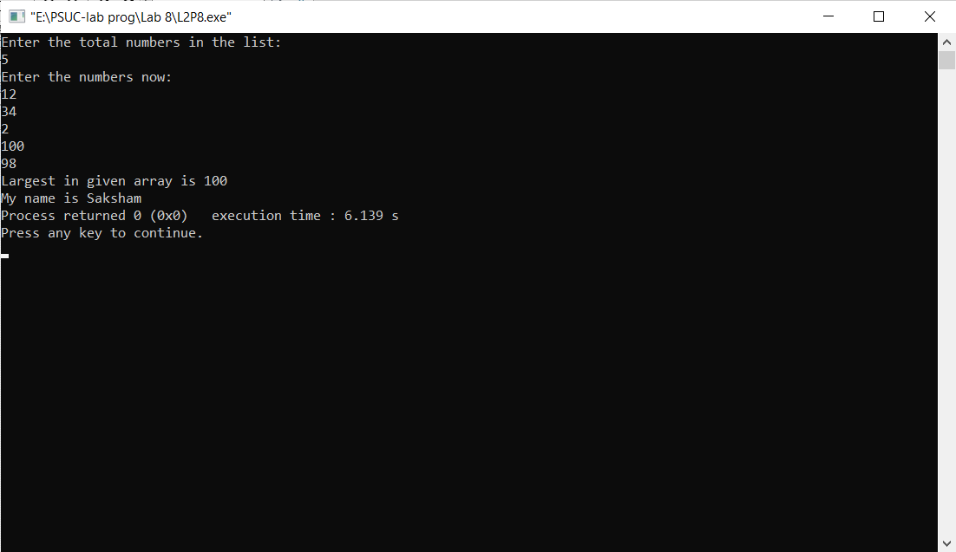

Q3) Write a function IsPalin to check whether the given string is a palindrome or not. Write a main function to test this function.

**Code**:

#include<stdio.h>

int IsPalin(char[]);

int main()

{

char arr[100];

printf("Enter string:\n");

gets(arr);

int palin=IsPalin(arr);

if(palin==0)

printf("Is a Palindrome");

else

printf("Not a Palindrome");

printf("\nMy name is Saksham");

return 0;

}

int IsPalin(char arr[100])

{

int i,n=0,flag=0;

for(i=0;arr[i]!='\0';i++)

n++;

for(i=0;i<=n/2;i++)

{

if(arr[i]!=arr[n-1-i])

{

flag=1;

break;

}

}

return flag;

}

**Outputs**:

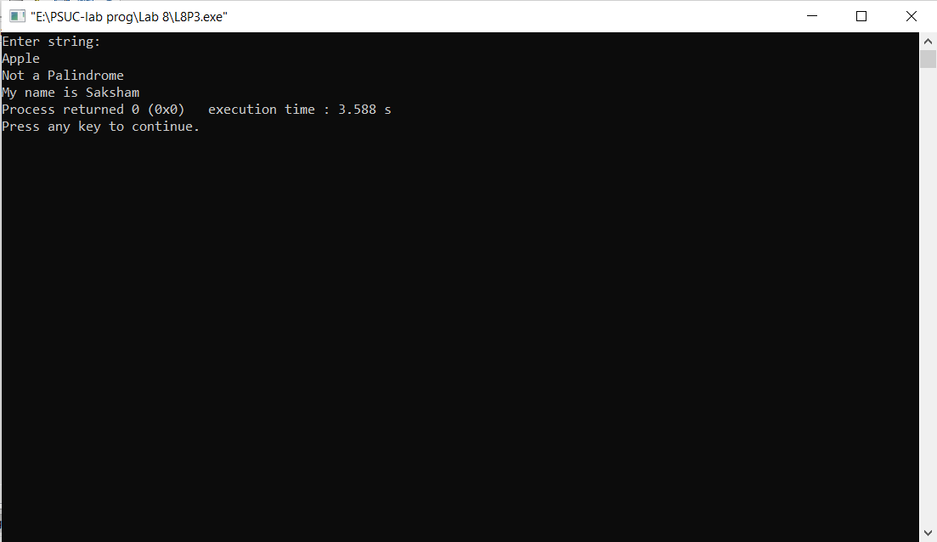

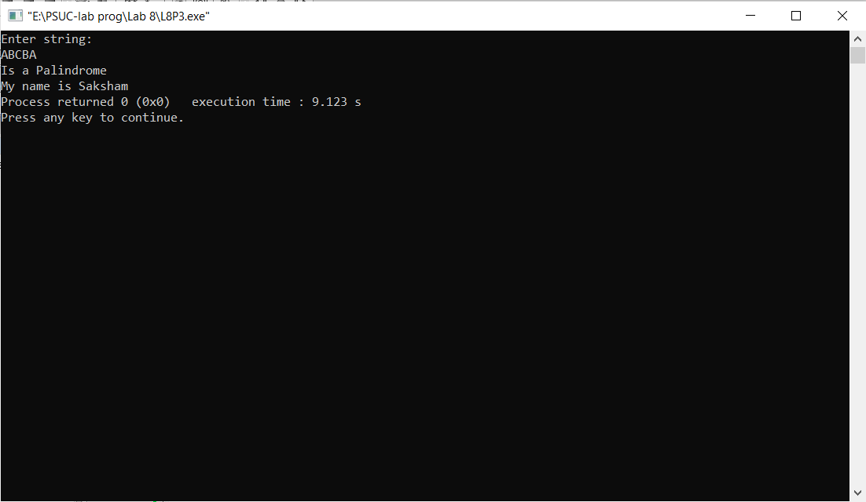

Q4) Write a function CornerSum which takes as a parameter, no. of rows and no. of columns of a matrix and returns the sum of the elements in the four corners of the matrix. Write a main function to test the function.

**Code**:

#include<stdio.h>

int CornerSum(int[][100],int,int);

int main()

{

int a[100][100], temp[100][100];

int n,m;

printf("Enter the number of rows & columns of the array:\n");

scanf("%d%d",&m,&n);

printf("Enter the elements of the array:\n");

for(int i=0;i<m;i++)

{

for(int j=0;j<n;j++)

scanf("%d",&a[i][j]);

}

printf("\nThe matrix is:\n");

for (int i=0;i<m;i++)

{

for (int j=0;j<n;j++)

{

temp[i][j]=a[i][j];

printf("%d\t",temp[i][j]);

}

printf("\n");

}

int res=CornerSum(a,m,n);

printf("The sum of corner elements is %d.",res);

printf("\nMy name is Saksham");

return 0;

}

int CornerSum(int a[][100],int m,int n)

{

int sum=0;

sum=a[0][0]+a[0][n-1]+a[m-1][n-1]+a[m-1][0];

return sum;

}

**Output**:

